Virtual Key for Your Repositories:

Repository:

https://github.com/vdeepak19/Simplilearn_Phase-1-_Implement_OOPS_using_JAVA_with_Data_Structures_and_Beyond-Project/upload

Upon cloning the provided ‘Virtual Key for Your Repositories’ repository from github the following program is given:

# Features

## Core Business-level operations:

* Option to add a user specified file to the application
* Option to delete a user specified file from the application
* Option to search a user specified file from the application
* Navigation option to close the current execution context and return to the main context
* Option to close the application

## Additional Business-level operations:

* Option to display the existing files in current directory in ascending order
* Option to switch between existing directories
* Option to add sub level directory to the main directory of the application

# Sprints

## Sprint 1:

* Plan out the flow of the application(flowchart) with the required business-level operations
* Come up with and implement additional business-level operations to enhance user experience without compromising main business logic

## Sprint 2:

* Plan application architecture and custom exceptions
* Plan implementation of core business-level operations(data-structures and algorithms)

## Sprint 3:

* Pseudocode planned architecture and implementation

## Sprint 4:

* Turn Pseudocode into working prototype of application

## Sprint 5:

* Fix bugs and test working prototype
* Deploy

# Flow Chart of LockMePrototype

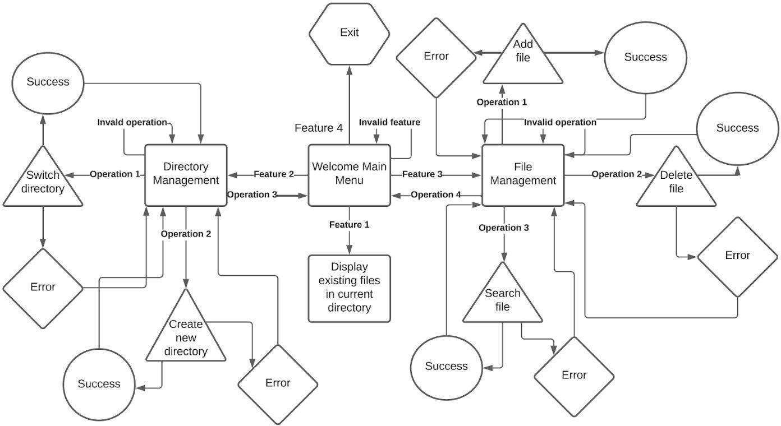

## Exceptions:

Contains:

* + - DirectoryNotFoundException.java
    - FailCreateDirectoryException.java
    - FailCreateFileException.java
    - FileDoesNotExistException.java
    - InvalidFileNameException.java
    - IsNotDirectoryException.java
    - NullDirectoryException.java

DirectoryNotFoundException.java FailCreateDirectoryException.java FailCreateFileException.java

FileDoesNotExistException.java InvalidFileNameException.java IsNotDirectoryException.java

NullDirectoryException.java

# Usage

Once run, the console will welcome and prompt the user for the feature that they want to perform.

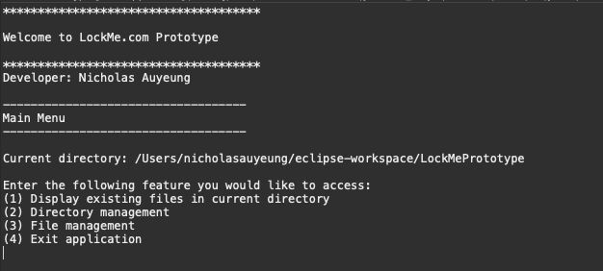

Enter the corresponding integer beside the feature you would like to select

**Feature 1** (Display existing files in current directory)

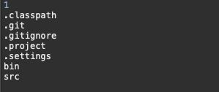*upon entering ‘1’ the list of files in current working directory will output

**Feature 2**(Directory Management)

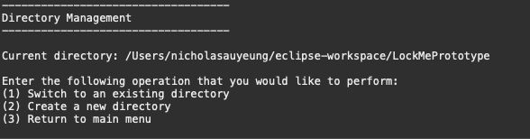*upon entering ‘2’ you will be taken to the ‘Directory Management’ sub-menu

Enter the corresponding integer beside the operation you would like to select Operation 1(Switch to an existing directory)

*upon entering ‘1’ you will be prompted to enter a directory name

If you would like to switch to the default directory enter ‘default’ otherwise enter a valid existing directory name

*if successful you will see the ‘Directory exists’ message on the console and the current directory will be switched to the stated directory, otherwise you will see an error

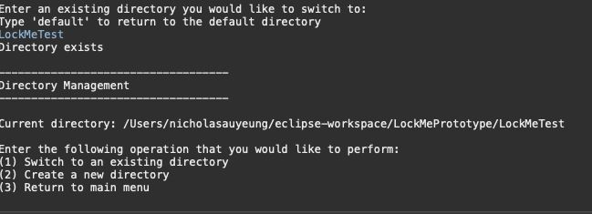message.

Operation 2(Create a new directory)

*upon entering ‘2’ you will be prompted to enter a directory name

Enter a valid directory name to create

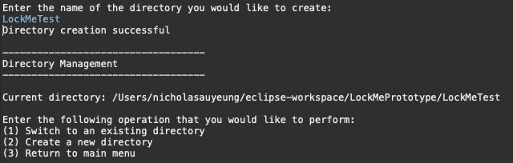*If successful you will see the ‘Directory creation successful’ message on the console and the current directory switched to the new directory, otherwise you will see an error message.

Operation 3(Return to main menu)

*upon entering ‘3’ you will be returned to the main menu and see ‘Returning to main menu…”



**Feature 3**(File Management)

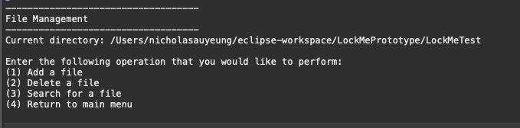*upon entering ‘3’ you will be taken to the ‘File Management’ sub-menu

Operation 1(Add a file)



Enter a valid file name to add

*If successful you will see the ‘File creation succeeded’ message on the console and the file will be added to your current working directory.

Operation 2(Delete a file)

Enter a valid file name to delete

*If successful you will see the ‘File deleted’ message on the console and the file will be deleted from your current working directory.

Operation 3(Search for a file)

Enter a valid file name to search for

*If successful you will see the ‘File file name is found’ message on the console



## Exiting

When finished with all operations, return to the main menu and enter ‘4’ to exit application.